Healthy Eating During Pregnancy: A Guide to the Foods for You and Your Baby

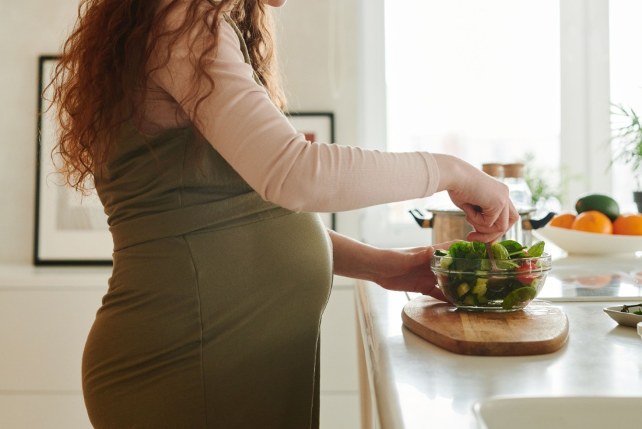
Pregnancy is an exciting time filled with many changes, and one of the most important ways to support a healthy pregnancy is through good nutrition. Every meal provides an opportunity to nourish both your body and your growing baby. While no single "superfood" can guarantee a healthy pregnancy, eating a balanced diet rich in essential nutrients helps support your baby's development, reduces the risk of certain pregnancy complications, and promotes your overall wellbeing.

Why Healthy Eating Matters During Pregnancy
Your nutritional needs increase during pregnancy because your body is supporting:
- Growth of the fetus, placenta
- Development of your baby's brain, bones, muscles, and organs
- Increased maternal blood volume
- Breast tissue preparation for breastfeeding
A nutritious balanced diet can also help lower the risk of:
- Iron-deficiency anemia
- Neural tube defects
- Constipation
- Excessive fatigue
- Gestational diabetes (when combined with healthy lifestyle habits)
- Poor fetal growth
Rather than "eating for two," focus on eating better, not simply more. Most pregnant women only need modest increases in calorie intake during pregnancy.

Essential Nutrients During Pregnancy
- Folate (Folic Acid)
Folate is one of the most important nutrients during early pregnancy because it helps prevent neural tube defects affecting the baby's brain and spinal cord.
Good food sources include:
- Dark green leafy vegetables, Spinach
- Kale, Broccoli
- Lentils, Chickpeas, Beans, legumes
- Oranges, Avocados
- Fortified breakfast cereals
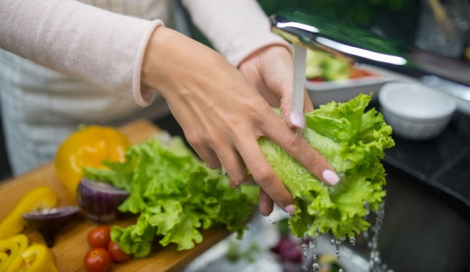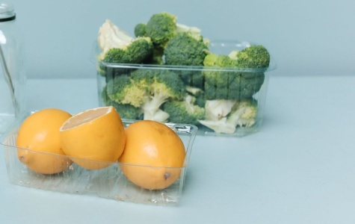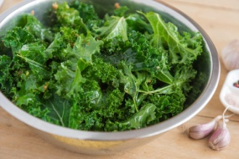
Even with a healthy diet, healthcare providers recommend taking folic acid supplements before conception and during early pregnancy.
- Protein
Protein supports your health and baby's growth and helps build:
- Muscles
- Organs
- Skin
- Placenta
Healthy protein-rich foods include:
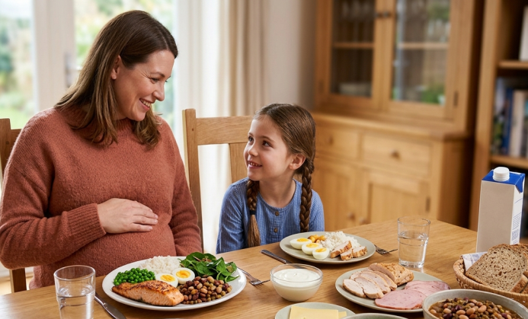
- Eggs
- Chicken
- Lean beef
- Fish low in mercury
- Lentils, Beans, nuts
- Yogurt, Cottage cheese, Milk

- Calcium
Calcium supports healthy development of:
- Bones, Teeth, Heart, Nerves, Muscles
Good calcium-rich foods include:
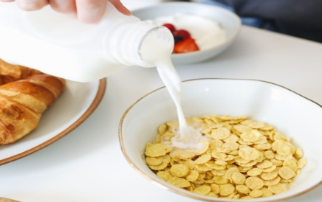
- Milk, Yogurt, Cheese
- Fortified plant-based milk

- Iron
Iron helps produce red blood cells needed during pregnancy and prevents anemia.
Iron-rich foods include:
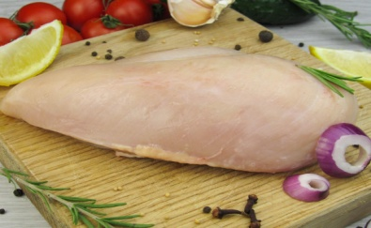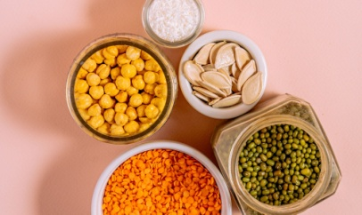
- Lean red meat
- Chicken
- Turkey
- Lentils, Beans, Pumpkin seeds
- Spinach
- Fortified cereals
Eating vitamin C-rich foods such as oranges, strawberries, kiwi, tomatoes, or bell peppers alongside iron-containing foods improves iron absorption.
- Omega-3 Fatty Acids
Omega-3 fats, particularly DHA, are important for:
- Brain development
- Nervous system development
Healthy sources include:
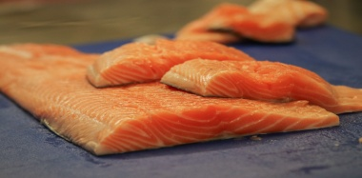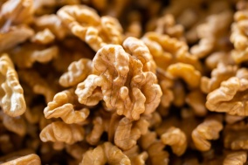
- Salmon, Sardines, Trout
- Walnuts
- Omega-3 Enriched Eggs
- Fortified Dairy products
Choose fish that are low in mercury and avoid high-mercury species such as shark, swordfish, king mackerel, and marlin.
- Fiber
Pregnancy hormones slow digestion, making constipation common.
Fiber helps:
- Improve bowel movements
- Promote healthy digestion
- Reduce constipation
- Support healthy blood sugar control
High-fiber foods include:
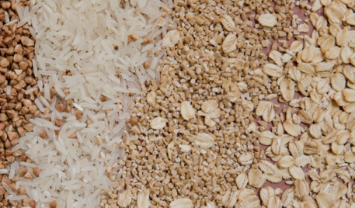
- Whole grains
- Oats, Brown rice
- Whole wheat bread
- Fruits, Vegetables
- Beans, Lentils,
Drink plenty of water to help fiber work effectively.
- Vitamin D
Vitamin D helps your body absorb calcium and supports healthy bones and immune function.
Sources include:
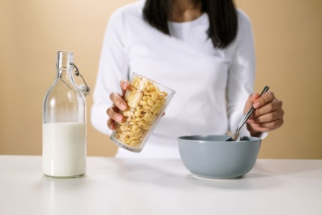
- Fortified milk
- Fortified cereals
- Eggs
- Oily fish
- Safe sunlight exposure
Many pregnant women may require vitamin D supplementation because food sources alone may not provide enough.
- Iodine:
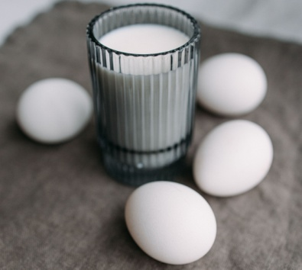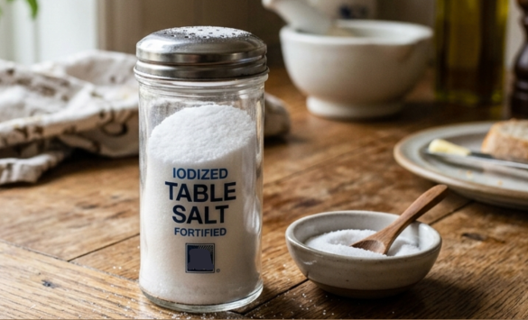
Iodine requirements rise markedly during pregnancy and lactation. Adequate intake is essential because iodine supports healthy fetal brain and neurocognitive development. Most women of reproductive age typically consume enough iodine, but those who rarely eat dairy products, eggs, seafood, or who do not use iodized salt may fall short of the increased demands during pregnancy and breastfeeding. Pregnant women should make sure that any salt used in cooking or at the table is iodized. Because iodine needs rise during pregnancy and breastfeeding, some women may also require an iodine-containing supplement to meet recommended intake.
Choline:
Choline needs rise significantly during pregnancy and lactation. Getting enough choline during these stages helps restore maternal stores and supports healthy development of the baby’s brain and spinal cord.
Many women do not meet the recommended choline intake during pregnancy. Choline is found across several food groups, with notable sources including eggs, dairy, meats, safe seafood, beans, peas, and lentils.
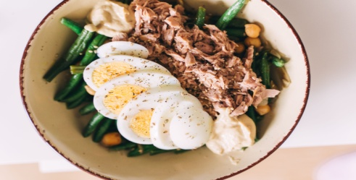
Food should ideally provide the needed choline, but women who are unsure about meeting recommendations should speak with their healthcare provider to determine whether choline supplementation is appropriate.

The Healthy Foods to Eat During Pregnancy

Fruits
Fresh fruits provide vitamins, minerals, antioxidants, and fiber.
Excellent choices include:
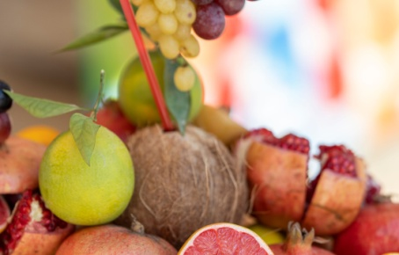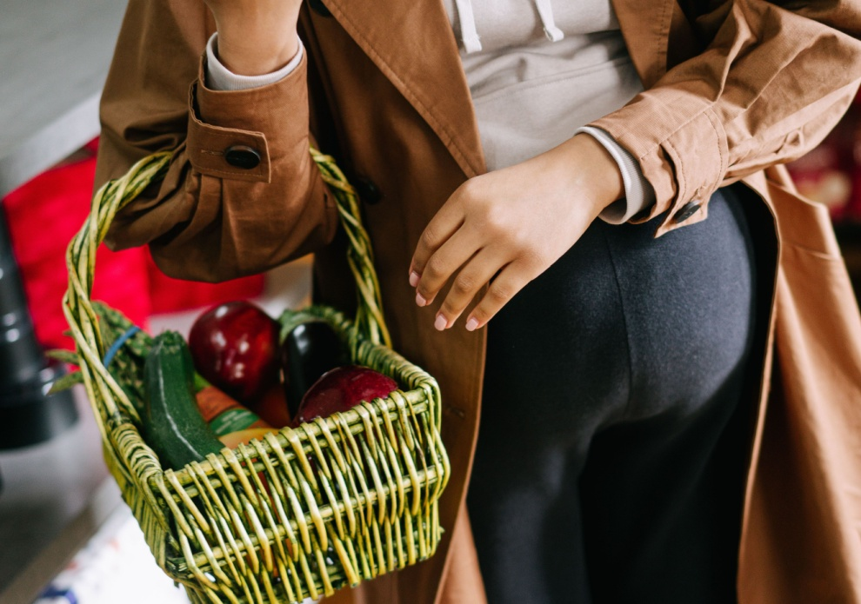
- Apples, Bananas, Oranges, Berries
- Pears, Mangoes, Kiwi, Grapes, Pomegranates
Aim for a variety of colorful fruits throughout the week.

Vegetables
Vegetables are rich in vitamins, minerals, and antioxidants.
Try to include:
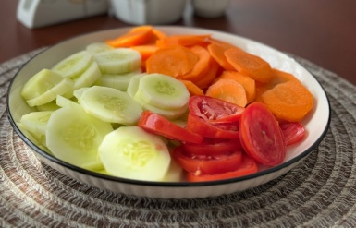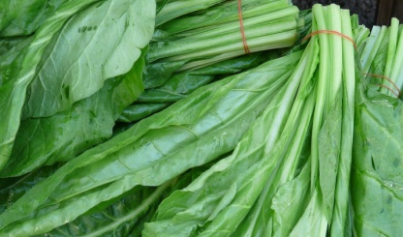
- Spinach, Kale, Broccoli, Carrots
- Sweet potatoes, Bell peppers, Tomatoes
- Cucumbers, Cauliflower, Green beans
A colorful vegetables plate often provides a wider range of nutrients.

Whole Grains
Whole grains provide energy, fiber, and vitamins.
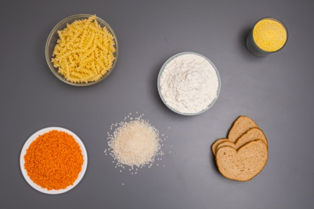
Options: Oatmeal, Brown rice, Whole wheat bread, Whole wheat pasta, Whole grain cereals.
Whole grains help maintain steady energy levels throughout the day.

Dairy Foods
Dairy products are rich in calcium, iodine and protein.
Healthy options include:
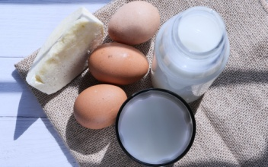
- Pasteurized Milk, Yogurt,
- Cheese made from pasteurized milk, Cottage cheese
Choose lower-fat options if recommended by your healthcare provider.

Healthy Fats
Healthy fats give you energy and support fetal development.
Good choices include:
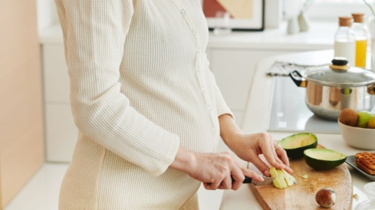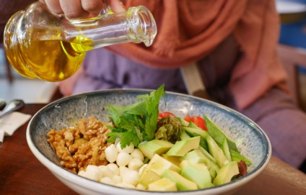

- Avocados
- Olive oil
- Nuts, Seeds
These foods also help you feel satisfied after meals.

Healthy Snacks During Pregnancy
Nutritious snacks can help maintain energy between meals.
Examples include:
- Yogurt with berries, Apple slices
- Small sandwiches or bread filled with grated cheese, mashed tuna, salmon, or sardines, served with salad.
- Salad vegetables such as carrot, celery, or cucumber.
- Handful of unsalted nuts
- Cheese and whole grain crackers
- Hummus with vegetables
- Boiled eggs
- Fresh fruit, Cottage cheese
- Oatmeal
- Smoothies made with milk, yogurt and fruit

Staying Hydrated


Water is essential during pregnancy.
Adequate hydration supports:
- Increased blood volume
- Amniotic fluid
- Digestion
- Kidney function
- Prevention of constipation
Aim to drink enough water throughout the day, increasing intake during hot weather or exercise.

Foods to Limit or Avoid
Certain foods carry a higher risk of foodborne illness or excessive exposure to harmful substances.
Avoid:
- Raw or undercooked meat. There’s a small risk of toxoplasmosis from eating raw, undercooked, or cured meat, and this infection can lead to miscarriage. Cold-cured, ready-to-eat meats can also contain Listeria, which may cause listeriosis. Listeriosis can result in miscarriage or stillbirth, and can make a newborn baby ill.
- Raw fish and raw shellfish. High-mercury fish.
- Raw eggs. Salmonella can cause food poisoning, which may make you seriously unwell.
- Unpasteurized milk, yoghurt, Soft cheeses made from unpasteurized milk. Unpasteurised dairy products can carry Listeria, a bacterium that causes listeriosis. This infection can lead to miscarriage, stillbirth, or severe illness in a newborn baby.
- Excess alcohol. Drinking alcohol during pregnancy can cause long-term harm to your baby, so the safest choice is to avoid alcohol entirely.
- Excessive caffeine. You should keep your daily caffeine intake below 200 mg, as higher amounts have been linked to an increased risk of miscarriage and stillbirth.
Wash fruits and vegetables thoroughly before eating.

Healthy Eating Tips
Simple habits can make healthy eating easier.
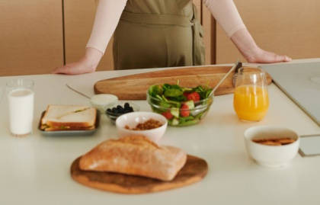
- Eat regular meals. Avoid long intervals between meals.
- Include protein in your meal.
- Fill half your plate with vegetables.
- Choose whole grains over refined grains.
- Eat a variety of colorful foods.
- Limit sugary drinks.
- Reduce highly processed foods.
- Read food labels.
- Take prenatal vitamins as advised by your healthcare provider.
Prepare meals safely.
- Wash fruit, vegetables and salads thoroughly to remove soil that may contain toxoplasma.
- Clean hands, surfaces and utensils before and after preparing raw foods to reduce the risk of food poisoning.
- Store raw foods separately from ready-to-eat foods to prevent contamination.
- Use separate knives and chopping boards for raw meat and other foods.
- Heat ready meals until steaming hot throughout, especially those containing poultry.
- Check use-by dates and avoid eating food past its use-by date.
- Ensure foods like eggs, poultry, burgers, sausages, and whole cuts of lamb or beef are cooked thoroughly until steaming hot all the way through.
Women who follow vegetarian or vegan eating patterns during pregnancy:
Women who follow vegetarian or vegan eating patterns during pregnancy may need to pay extra attention to meeting their nutrient needs. Iron can be a particular concern because plant foods provide only non-heme iron, which is less readily absorbed than heme iron. Vitamin B12 is another key nutrient, as it is found exclusively in animal-derived foods.
Pregnant women who eat vegetarian or vegan diets should speak with a healthcare provider to determine whether they need supplements such as iron, vitamin B12, or other nutrients including choline, zinc, iodine, or DHA.
When to Seek Professional Advice
Speak with your healthcare provider or a registered dietitian if you:
- Have severe nausea, vomiting, diarrhea
- Have gestational diabetes
- Have food allergies
- Have significant weight loss
- Have concerns about weight gain
- Have anemia or nutritional deficiencies
- Follow a vegetarian or vegan diet
Individual nutritional needs vary, and personalized advice is often the best approach.
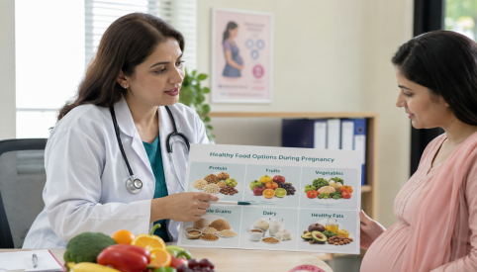
Healthy eating during pregnancy is not about following a perfect diet—it is about making consistent, nutritious choices that support both you and your baby's health. A balanced diet rich in fruits, vegetables, whole grains, lean proteins, dairy or fortified alternatives, healthy fats, and plenty of water provides most of the nutrients needed for a healthy pregnancy.
Remember that prenatal vitamins complement, but do not replace, a healthy diet. Regular antenatal care, food safety, appropriate supplementation, and guidance from your healthcare provider all play important roles in supporting a healthy pregnancy and giving your baby the best possible start in life.

Frequently Asked Questions (FAQs)

Can I eat eggs during pregnancy?
Yes. Fully cooked eggs are an excellent source of protein, choline, and vitamins. Avoid raw eggs.

Is fish safe during pregnancy?
Fish such as salmon, sardines and trout, are safe and provide beneficial omega-3 fatty acids. However to limit the use of:
- Oily fish (salmon, trout, mackerel, sardines, herring) – no more than 2 portions per week
Avoid high-mercury fish such as Shark, Swordfish, Marlin.

How much water should I drink?
Most pregnant women should drink enough fluids to stay well hydrated, though individual needs vary depending on activity level, climate, and medical conditions.

Do I need prenatal vitamins if I eat well?
Prenatal vitamins help provide nutrients such as folic acid, iron, and vitamin D that may be sometime difficult to obtain in sufficient amounts through diet alone.

Can I drink coffee?
Moderate caffeine intake is generally considered acceptable during pregnancy, but total caffeine should be limited to less than 200 mg per day, following current recommendations.

What foods can help relieve constipation during pregnancy?
High-fiber foods such as whole grains, oats, fresh fruits, vegetables, beans, lentils and chia seeds, can help prevent constipation. Drinking plenty of water and staying physically active, if medically appropriate, can also improve bowel function.
Button: References
The health content is built on evidence-based research and reviewed by medical experts to ensure it stays accurate, trustworthy, and aligned with current clinical standards.
Sources:
- World Health Organization. WHO Recommendations on Antenatal Care for a Positive Pregnancy Experience. WHO, 2016, https://www.who.int/publications/i/item/9789241549912. Accessed 12 July 2026.
- World Health Organization. Healthy Diet. WHO, https://www.who.int/news-room/fact-sheets/detail/healthy-diet. Accessed 12 July 2026.
- U.S. Department of Agriculture, and U.S. Department of Health and Human Services. Dietary Guidelines for Americans, 2020–2025. 9th ed., Dec. 2020, Chapter 5, "Women Who Are Pregnant or Lactating." Official PDF. Accessed 30 July 2026.
- National Health Service. Healthy Eating in Pregnancy. NHS, https://www.nhs.uk/pregnancy/keeping-well/have-a-healthy-diet/. Accessed 12 July 2026.
- U.S. Department of Health and Human Services, and U.S. Department of Agriculture. Dietary Guidelines for Americans, 2025–2030. 10th ed., Jan. 2026, https://cdn.realfood.gov/DGA.pdf. Accessed 30 July 2026.
- Centers for Disease Control and Prevention. Folic Acid. CDC, https://www.cdc.gov/folic-acid/. Accessed 12 July 2026.
- American College of Obstetricians and Gynecologists. Nutrition During Pregnancy. ACOG, https://www.acog.org/womens-health/faqs/healthy-eating-during-pregnancy ,Accessed 12 July 2026.
- National Health Service. Foods to Avoid in Pregnancy. NHS, https://www.nhs.uk/pregnancy/keeping-well/foods-to-avoid/. Accessed 12 July 2026.

